TABLE OF CONTENTS
CHAPTER ONE: INTRODUCTION 2
1.1 Background of the Study 2
1.2 Problem Statement 3
1.3 Objectives of the Study 3
1.3.1 General Objective 3
1.3.2 Specific Objectives 3
1.4 Research Questions 4
1.5 Significance of the Study 4
1.6 Scope of the Study 4
1.7 Limitations of the Study 5
CHAPTER TWO: LITERATURE REVIEW 6
2.1 Introduction 6
2.2 Conceptual Review 6
2.2.1 Job Vacancy 6
2.2.2 Internship 6
2.2.3 Recruitment 6
2.2.4 Electronic Recruitment (E-Recruitment) 7
2.2.5 Applicant Tracking System (ATS) 7
2.3 Theoretical Review 7
2.3.1 Technology Acceptance Model (TAM) 7
2.4 Review of Related Studies 8
2.4.1 Online Recruitment Systems 8
2.4.2 Internship Management Systems 8
2.4.3 Applicant Tracking Systems 8
2.4.4 Web-Based Recruitment Platforms 9
2.4.5 Relevance of the Reviewed Studies to Somali Fix Jobs 9
2.5 Review of Existing Systems 9
2.5.1 LinkedIn 9
2.5.2 Indeed 10
2.5.3 Glassdoor 10
2.5.4 Jobberman 11
2.6 Review of Technologies 11
2.7 Research Gap 12
2.8 Conceptual Framework 12
2.9 Summary 12
CHAPTER THREE: SYSTEM ANALYSIS AND RESEARCH METHODOLOGY 13
3.1 Introduction 13
3.2 System Analysis 13
3.3 Research Methodology 14
3.4 Functional Requirements 15
3.5 Non-Functional Requirements 16
3.6 Feasibility Study 17
3.6.1 Technical Feasibility 17
3.6.2 Economic Feasibility 17
3.6.3 Operational Feasibility 18
3.6.4 Schedule Feasibility 18
3.7 Use Case Analysis 18
3.8 System Design 19
3.8.1 System Architecture 20
3.8.2 Database Design 20
3.8.3 UML Diagrams and Flowcharts 23
3.8.4 User Interface Design 26
3.9 Hardware and Software Requirements 26
3.10 Chapter Summary 26
REFERENCES 28

CHAPTER ONE: INTRODUCTION

1.1 Background of the Study
Information and Communication Technology (ICT) has significantly transformed the way organizations, institutions, and individuals communicate, share information, and conduct business activities. One of the sectors greatly influenced by this technological advancement is recruitment and internship placement, where employers and job seekers increasingly depend on digital platforms instead of traditional recruitment methods.
Globally, online recruitment systems have become an effective solution for connecting employers with qualified job seekers. These systems improve the efficiency of the recruitment process by enabling organizations to advertise vacancies electronically while allowing applicants to search and apply for available opportunities from any location with internet access.
Traditionally, job vacancies and internship opportunities have been advertised through newspapers, notice boards, radio announcements, and word of mouth. Although these methods have been useful for many years, they are often slow, limited in coverage, expensive, and difficult to manage. Job seekers, especially university students and fresh graduates, frequently experience difficulties locating suitable employment and internship opportunities, while employers face challenges in managing applications manually and identifying qualified candidates efficiently.
An Online Job Vacancy and Internship Management System provides a centralized web-based platform where employers can post job vacancies and internship opportunities, manage applications, and communicate with applicants. At the same time, job seekers can register, create profiles, search for available opportunities, submit applications online, and receive notifications regarding their application status.
Therefore, this study focuses on the design, development, and implementation of an Online Job Vacancy and Internship Management System that simplifies recruitment processes, improves transparency, reduces administrative workload, and provides an efficient communication platform between employers and job seekers.

1.2 Problem Statement
There is no unified, structured, and moderated digital platform in Somalia that connects job seekers with companies offering full-time jobs and internships, tracks the full lifecycle of an application from submission to hiring decision, and gives an administrative body the ability to verify companies and oversee activity on the platform. In the absence of such a system: job seekers apply blindly with no confirmation their application was received or seen; companies receive applications through disconnected, informal channels with no consistent format and no way to compare candidates fairly; and there is no oversight verifying that a company posting opportunities is a legitimate, real organization. This combination of problems results in inefficient hiring, reduced access to opportunity for candidates outside personal networks, and low trust between the two sides of the labor market.

1.3 Objectives of the Study

1.3.1 General Objective
To design and develop a web-based employment, internship, and career development platform that connects job seekers and companies in Somalia through a structured, verifiable, and role-based system.

1.3.2 Specific Objectives
1. To allow companies to register, be verified by an administrator, and publish job and internship opportunities.
2. To allow job seekers to build a career profile and apply to opportunities that match their interests.
3. To provide a structured application pipeline so both companies and job seekers can track the progress of an application.
4. To provide messaging and a notification system so both parties stay informed of important events.
5. To provide an administrative portal for verifying companies, managing users, and monitoring overall platform activity.
6. To support multiple languages (English, Somali, and Arabic) to make the platform accessible to its target audience.

1.4 Research Questions
1. How will a mobile-responsive web-based system improve access to job and internship opportunities for Somali youth?
2. How will an online recruitment system improve the efficiency of companies in finding qualified candidates?
3. How will internship opportunities be managed through a centralized digital platform?
4. What features will be required to develop an effective and scalable job and internship system?

1.5 Significance of the Study
For job seekers, the system provides a single, searchable, and trustworthy place to discover verified opportunities and track every application in one dashboard. For companies, it provides a structured applicant pipeline and a consistent way to compare and shortlist candidates without geographic constraints. For the wider Somali labor market, a moderated platform of this kind can reduce the information gap between job seekers and employers and make hiring more transparent and merit-based. Academically, the project also demonstrates a complete, iterative software development lifecycle — from requirements analysis through a working, tested system.

1.6 Scope of the Study
The system covers four user roles — Job Seeker, Company, Administrator, and Content Writer — and the following functional areas: account registration and role-based authentication; job and internship posting and browsing; the full application lifecycle from submission to hiring decision; direct messaging between job seekers and companies; in-app notifications; and an administrative portal for company verification, user management, content moderation, reporting, and system configuration. The scope is limited to a web-based platform (no native mobile application) and to features that can be demonstrated on a self-hosted XAMPP environment without paid third-party services.

1.7 Limitations of the Study
The system does not currently include real outbound email delivery (e.g. via SMTP), so features such as password-reset OTPs and application reminders operate through in-app channels rather than email in this version. It also does not include a native mobile application, payment processing, or integration with any government business-registration database for automated company verification — verification is performed manually by an administrator reviewing submitted documents. These limitations are discussed further, alongside recommendations to address them, in Chapter Five.

CHAPTER TWO: LITERATURE REVIEW

2.1 Introduction
This chapter reviews the literature related to online recruitment systems, internship management platforms, and the technologies used to develop web-based employment systems. It discusses the conceptual review, theoretical review, review of related studies, review of existing systems, review of technologies, research gap, conceptual framework, and chapter summary. The purpose of this chapter is to establish the theoretical and technical foundation for the design and development of the Online Job Vacancy and Internship Management System.

2.2 Conceptual Review

2.2.1 Job Vacancy
A job vacancy refers to an available employment position within an organization that requires qualified candidates to perform specific duties and responsibilities. Employers advertise job vacancies to attract suitable applicants based on required qualifications, experience, and skills. Traditionally, vacancies were advertised through newspapers and notice boards, but modern organizations increasingly use online recruitment platforms to reach a larger audience.

2.2.2 Internship
An internship is a short-term work experience program designed to provide students and recent graduates with practical skills related to their academic field. Internships help participants gain professional experience, improve employability, and prepare for future careers while assisting organizations in identifying potential future employees.

2.2.3 Recruitment
Recruitment is the process through which organizations identify, attract, evaluate, and select qualified individuals for employment opportunities. Effective recruitment ensures that organizations hire competent employees capable of achieving organizational objectives.

2.2.4 Electronic Recruitment (E-Recruitment)
Electronic recruitment, commonly known as e-recruitment, is the use of internet technologies to support recruitment activities. Employers publish vacancies online while applicants submit applications electronically. E-recruitment reduces recruitment costs, shortens hiring time, increases transparency, and allows applicants to apply from any location.

2.2.5 Applicant Tracking System (ATS)
An Applicant Tracking System (ATS) is software used to manage recruitment activities electronically. It stores applicant information, tracks application status, filters candidates, and assists recruiters in selecting qualified applicants efficiently.

2.3 Theoretical Review

2.3.1 Technology Acceptance Model (TAM)
Author: Fred Davis
Year Developed: 1989
Concept of the Theory
The Technology Acceptance Model (TAM) explains how users accept and use new information systems. According to Davis (1989), users are more likely to adopt a technology when they believe it is useful and easy to use.
The model consists of two major constructs:
Perceived Usefulness (PU): Users believe that the system improves their performance.
Perceived Ease of Use (PEOU): Users believe that the system is simple to learn and operate.
Relevance of TAM to this Study
The Technology Acceptance Model is appropriate for this study because both employers and job seekers are expected to use the proposed online recruitment platform.
For employers, the system simplifies vacancy posting and application management.
For job seekers, the platform enables easy registration, job searching, internship applications, and application tracking.
If users perceive the system as useful and easy to use, they are more likely to adopt it successfully.

2.4 Review of Related Studies

2.4.1 Online Recruitment Systems
A study by Parry and Tyson (2008) examined the use of online recruitment methods and their impact on organizational recruitment practices. The study found that e-recruitment can help organizations reach a wider pool of applicants, improve the speed of recruitment, and reduce some administrative costs associated with traditional recruitment methods. The researchers also emphasized that organizations need to integrate online recruitment with their overall recruitment strategies to achieve better results. This study is relevant to the proposed Somali Fix Jobs platform because it demonstrates how online recruitment technologies can improve the connection between employers and job seekers.

2.4.2 Internship Management Systems
Narayanan, Olk, and Fukami (2010) conducted a study on internship programs and examined factors that influence the effectiveness of internships. Their research highlighted the importance of proper coordination, communication, and structured management between students and organizations. The study showed that well-organized internship programs can provide students with valuable practical experience while helping organizations identify potential future employees. This finding is relevant to Somali Fix Jobs because the proposed system includes an internship management component that allows organizations to advertise internship opportunities and students to apply for them online.

2.4.3 Applicant Tracking Systems
A study by Boehle (2000) discussed the increasing use of technology in recruitment and the role of automated systems in managing job applicants. The study indicated that recruitment technologies can help organizations manage large numbers of applicants more efficiently and support the collection and organization of applicant information. Applicant Tracking Systems can therefore reduce the amount of manual work involved in recruitment and make candidate management more organized. This is relevant to Somali Fix Jobs because the proposed platform will provide employers with tools for receiving, organizing, and reviewing applications electronically.

2.4.4 Web-Based Recruitment Platforms
Cappelli (2001) examined the transformation of recruitment through the use of Internet technologies. His study explained that online recruitment changed the traditional hiring process by enabling organizations to advertise vacancies and communicate with potential candidates through digital platforms. The study also highlighted the importance of using technology to make recruitment faster and more efficient. This is closely related to Somali Fix Jobs because the proposed platform is designed to provide a centralized web-based environment where employers can publish vacancies and applicants can search and apply for employment opportunities.

2.4.5 Relevance of the Reviewed Studies to Somali Fix Jobs
The reviewed studies demonstrate that digital recruitment technologies can improve the efficiency, accessibility, and organization of recruitment and internship processes. Parry and Tyson (2008) emphasized the benefits of e-recruitment, while Narayanan et al. (2010) demonstrated the importance of structured internship programs. Boehle (2000) highlighted the role of technology in managing applicants, and Cappelli (2001) discussed how Internet technologies transformed traditional recruitment practices.
However, these studies were mainly conducted in contexts outside Somalia. Therefore, there is a need for a localized web-based platform that considers the specific employment and internship needs of Somali job seekers, students, and employers. The proposed Somali Fix Jobs platform seeks to address this gap by providing a centralized system for job vacancy publication, internship opportunities, online applications, and applicant management.

2.5 Review of Existing Systems

2.5.1 LinkedIn
LinkedIn is one of the world's largest professional networking platforms. It allows employers to publish vacancies while job seekers create professional profiles and apply for employment opportunities.
Strengths
• Professional networking
• Company profiles
• Job recommendations
• Skill endorsements
Limitations
• Premium features require payment.
• Limited focus on internships in developing countries.

2.5.2 Indeed
Indeed is a global employment search engine that aggregates vacancies from thousands of organizations worldwide.
Strengths
• Large number of vacancies
• Advanced job search
• Resume upload
Limitations
• High competition
• Many duplicate advertisements

2.5.3 Glassdoor
Glassdoor provides job listings together with company reviews, salaries, and interview experiences.
Strengths
• Company reviews
• Salary information
• Interview experiences
Limitations
• Some information may be outdated.

2.5.4 Jobberman
Jobberman is an African recruitment platform connecting employers with job seekers.
Strengths
• African-focused recruitment
• Internship opportunities
• Career advice
Limitations
• Limited availability in Somalia.

2.6 Review of Technologies
HTML
HyperText Markup Language (HTML) is the standard markup language used to structure web pages. In this project, HTML is used to create forms, navigation menus, tables, and page layouts.
CSS
Cascading Style Sheets (CSS) control the presentation and visual appearance of web pages. CSS is used to create responsive layouts, colors, typography, and user-friendly interfaces.
JavaScript
JavaScript adds interactivity to web pages. It is used for client-side validation, dynamic page updates, modal windows, notifications, and interactive user interfaces.
AJAX
Asynchronous JavaScript and XML (AJAX) allows web pages to communicate with the server without reloading the entire page. In this project, AJAX improves user experience by loading notifications, messages, and application data dynamically.
Bootstrap
Bootstrap is a front-end CSS framework used to build responsive websites quickly. It provides ready-made components such as navigation bars, cards, forms, buttons, tables, and responsive grids.
PHP
PHP is the server-side scripting language used to implement the business logic of the system. It handles user authentication, job posting, internship management, application processing, messaging, and administrator functions.
MySQL
MySQL is the relational database management system used to store all system data, including user accounts, company profiles, vacancies, internship opportunities, applications, notifications, and messages.

2.7 Research Gap
Although numerous online recruitment platforms exist worldwide, few systems are specifically designed to address the recruitment challenges faced in Somalia. Most existing platforms do not provide localized features such as multilingual support (English, Somali, and Arabic), company verification by administrators, integrated internship management, structured application tracking, and centralized communication between employers and applicants.
This study addresses these gaps by developing an Online Job Vacancy and Internship Management System tailored to the Somali labor market, providing a secure, role-based, and user-friendly platform that supports both employment and internship opportunities.

2.8 Conceptual Framework
Independent Variables → Dependent Variable

2.9 Summary
This chapter reviewed the literature related to online recruitment systems, internship management, applicant tracking systems, existing employment platforms, and the technologies used in developing the proposed system. It also discussed the Technology Acceptance Model (TAM), reviewed previous studies, identified the research gap, and presented the conceptual framework. The findings of this chapter provide the theoretical and technological foundation for Chapter Three, which describes the research methodology and system development approach.

CHAPTER THREE: SYSTEM ANALYSIS AND RESEARCH METHODOLOGY

3.1 Introduction
This chapter presents the analysis and methodological foundation behind the development of Somali Fix Jobs, a web-based employment and internship platform built to connect Somali job seekers with companies operating in Somalia and the wider region. It covers the analysis of the existing (manual/informal) way job seeking is conducted, the research methodology followed during development, the functional and non-functional requirements of the system, a feasibility study, a use case analysis, and the overall system design — including the system architecture, database design, UML diagrams, flowcharts, and user interface design approach. Together, these sections document the reasoning that shaped every major decision made while building the platform.

3.2 System Analysis
Job seeking in Somalia today is still dominated by informal, fragmented channels: word of mouth, printed notices, personal social media posts, and scattered WhatsApp or Telegram groups shared among acquaintances. Companies that do advertise openings typically do so through a single social media post or a short newspaper notice, with no centralized place for a job seeker to discover multiple opportunities, compare them, or track the status of an application. This creates several concrete problems that motivated this project:
- No central discovery point — job seekers must monitor many disconnected sources instead of one platform.
- No application tracking — a candidate who sends a CV by email or WhatsApp has no way to see whether it was received, reviewed, or rejected.
- No structured company verification — anyone can claim to be hiring on social media, exposing job seekers to potential scams, with no vetting process.
- No standardized profile — job seekers repeat the same information (education, skills, experience) in a different format for every company they contact.
- No interview scheduling or communication channel — coordination happens ad hoc over phone calls or personal messaging apps, mixing personal and professional communication.
Somali Fix Jobs was designed directly against these gaps: it gives job seekers a single searchable catalogue of jobs and internships, a structured and reusable profile, visible application status tracking, and in-platform messaging; and it gives companies a vetted registration process (with license/document upload and administrator approval) before they are allowed to post positions, which introduces a basic trust layer that informal channels lack entirely.

3.3 Research Methodology
This project was developed as an applied, developmental (build-oriented) research project rather than a purely theoretical study — its primary output is a working, deployable software artifact, and the "research" activity is the systematic analysis, design, and evaluation carried out while building it. An iterative and incremental development methodology was followed, broadly similar in spirit to Agile practice, for the following reasons: requirements for a platform of this kind (multiple user roles, evolving feature set) are difficult to fully specify up front, and the developer/researcher benefited from continuously validating each module against a real, running instance of the system rather than against paper designs alone.
The methodology followed these repeating stages for each module (authentication, job seeker portal, company portal, admin portal, messaging, and so on):
- Requirements gathering — identifying the real-world task the module must support, drawing on the system analysis in Section 3.2 and on direct review of comparable job portals.
- Design — sketching the database tables, page flow, and role-based access rules needed for the module.
- Implementation — building the module directly in PHP against the live XAMPP/MariaDB stack described in Section 3.9.
- Testing against a live instance — every module was tested directly against a real, running MariaDB-backed installation on localhost rather than against mocked data, using both manual browser interaction and scripted HTTP requests (see Chapter Four, Section 4.3, for the full testing methodology).
- Refinement — issues found during testing (validation gaps, broken links between tables, usability friction) were fixed and re-tested before moving to the next module.
This build-test-refine cycle repeated across the life of the project, which is why several features documented in this thesis show a visible history of iteration: an initial design was implemented, tested, found to have a real limitation, and replaced with an improved approach — a pattern that is characteristic of iterative development and is reported honestly here as part of the research record rather than presented as though the final design were the only one considered.

3.4 Functional Requirements
The functional requirements below are derived directly from the features actually implemented and tested in the system, organized by user role.
Role | Functional Requirements
Job Seeker | Register and verify account via email OTP; sign in with email/password or Google; build a structured profile (bio, education, experience, skills, certificates, projects, CV upload); browse and search jobs/internships with filters; apply to listings with a cover letter and CV; bookmark listings; track application status; message companies directly; view scheduled interviews; receive in-app notifications; manage account settings and change password; switch site language (English/Somali/Arabic).
Company | Register a company account with license/verification document upload; await administrator approval before posting is enabled; manage a company public profile (logo, cover photo, about, mission); create, edit, publish, and close job and internship listings; review applicants and update application status through a pipeline (pending, reviewed, shortlisted, interview, accepted, rejected); schedule, reschedule, and cancel interviews; message applicants directly; receive notifications.
Admin / Super Admin | Approve, reject, or suspend company registrations; manage all user accounts and roles (super_admin, admin, company, job_seeker, content_writer, moderator, support, tester); moderate/remove job, internship, and blog content; view system-wide reports and export data to CSV; back up and restore the live database from the admin panel; configure system settings (branding, appearance, maintenance mode, UI sections); view activity logs and contact-form submissions; broadcast notifications to users.
Content Writer | Author, edit, and publish blog posts with a cover image, category, and tags; manage draft/published status of authored content.

3.5 Non-Functional Requirements
Category | Requirement
Performance | Pages should render within acceptable time on a standard XAMPP/Apache/MariaDB stack under normal load; full-text indexes are used on jobs, internships, and blogs to keep search responsive as data grows.
Security | CSRF tokens are required and validated on every state-changing form submission; passwords are stored using PHP's password_hash() (bcrypt); role-based access control (RBAC) restricts each page/action to the appropriate role(s); file operations such as database backup restoration guard against path traversal by only allowing an exact basename inside the designated backup directory; uploaded files are validated and stored outside of directly executable contexts where applicable.
Usability | The interface uses a consistent, mobile-responsive layout (Tailwind CSS) with role-appropriate dashboards, so each user type sees only the actions relevant to their role.
Availability | The system is designed to run continuously on a standard LAMP/WAMP-style stack (XAMPP in this project's development context) with minimal manual intervention.
Maintainability | The codebase follows a plain, page-per-feature procedural PHP structure (not a heavyweight MVC framework), organized into clear role-based directories (admin/, company/, jobseeker/, auth/, includes/), which keeps individual files small and easy to locate and modify.
Localization | The system supports three languages — English, Somali, and Arabic — through a central i18n mechanism, allowing the interface to switch language per user preference.

3.6 Feasibility Study

3.6.1 Technical Feasibility
The system is technically feasible: it is built entirely on freely available, well-documented, open-source technology — PHP 8, MariaDB, and the Apache web server, packaged conveniently for local development through XAMPP. No proprietary or licensed software is required to build, run, or extend the platform, and the plain procedural PHP approach keeps the technical barrier to entry low for future maintenance.

3.6.2 Economic Feasibility
The system was built with zero recurring software cost. All core dependencies (PHP, MariaDB, Apache) are free and open-source, and Tailwind CSS and Font Awesome are used via free tiers/CDN, which directly supports the project's zero-budget constraint as a student project.

3.6.3 Operational Feasibility
The platform is operationally feasible for its intended users: job seekers and company staff in the target market are already accustomed to using web forms and messaging apps, and the interface mirrors familiar patterns (dashboards, forms, chat threads, notification bells) from mainstream consumer software, keeping the learning curve low.

3.6.4 Schedule Feasibility
The project was carried out against a defined timeline, reproduced below from the official project guidelines.
Phase | Dates | Scope
Chapter Three: System Analysis and Research Methodology | Aug 15 - 20 | Complete system requirements analysis, feasibility study, use case analysis, methodology, and system specifications.
System Design | Aug 21 - 24 | System architecture, database design, UML diagrams, flowcharts, user interface mockups, and ER diagrams.
System Testing, Results, and Documentation (Chapter Four) | Sep 1 - 4 | Perform system testing, evaluate results, prepare screenshots, and complete Chapter Four.

Because the System Design phase (Aug 21-24) sits directly between and alongside the Chapter Three and Chapter Four phases in the official timeline rather than forming its own chapter, its output — system architecture, database design, UML diagrams, flowcharts, and interface mockups — is presented in this document as Section 3.8, System Design, within Chapter Three.

3.7 Use Case Analysis
Four actor types interact with the system: Job Seeker, Company, Admin / Super Admin, and Content Writer. A Job Seeker registers, verifies their account by OTP, builds a profile, and can then browse listings, apply, message companies, and join scheduled interviews. A Company registers with verification documents, waits for administrator approval, and can then manage listings, review applicants, and schedule interviews. An Admin (or Super Admin, which carries the full set of privileges) approves companies, manages users and content, and operates system-level tools such as reporting, CSV export, and database backup/restore. A Content Writer is a narrower role focused specifically on authoring and publishing blog content. The diagram below shows the primary use cases for each actor within the system boundary.
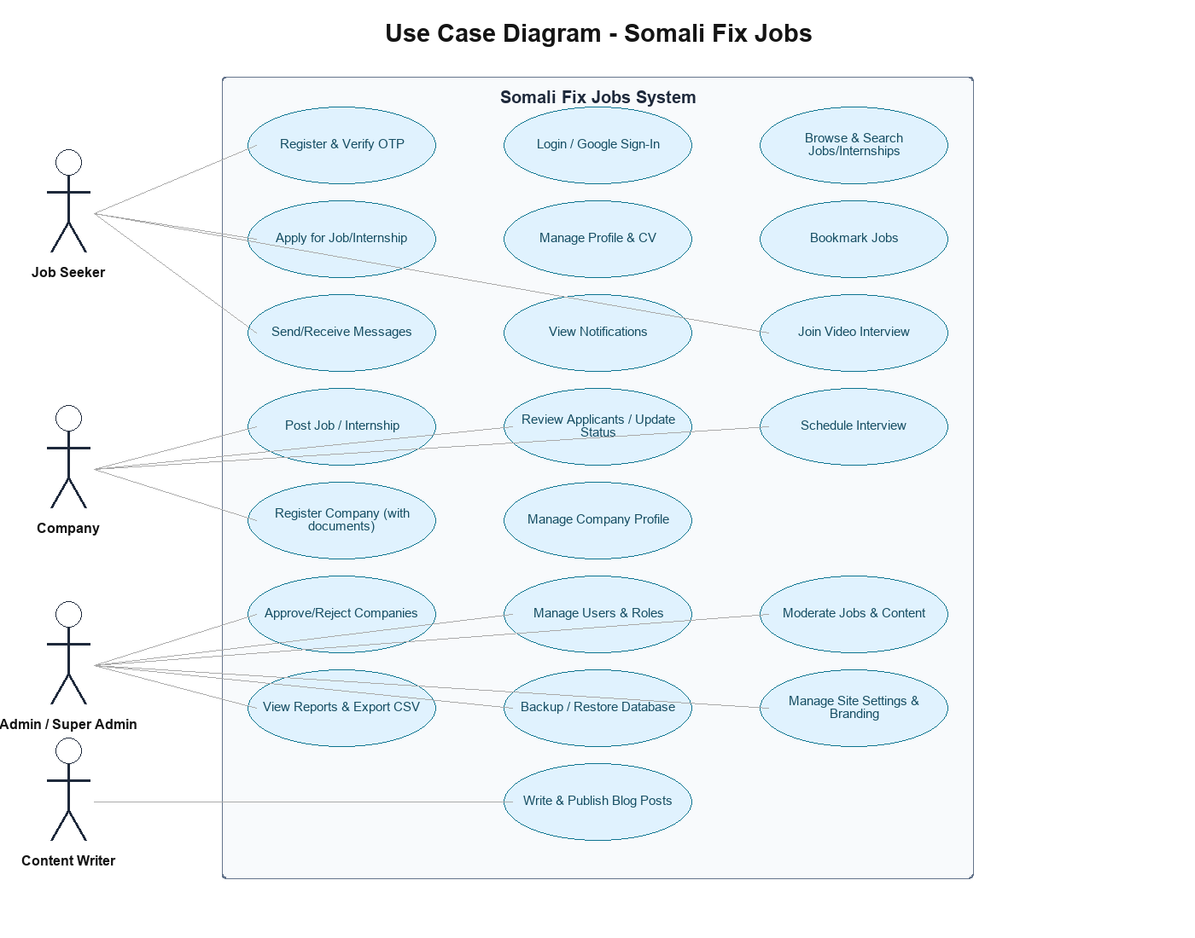
Figure 3.1: Use case diagram showing the four system actors (Job Seeker, Company, Admin/Super Admin, Content Writer) and their primary interactions with Somali Fix Jobs.

3.8 System Design
This section documents the system architecture, database design, UML/flowchart diagrams, and user interface design approach, corresponding to the System Design phase of the project timeline (Section 3.6.4).

3.8.1 System Architecture
Somali Fix Jobs follows a classic three-tier architecture: a presentation tier (the user's web browser rendering server-rendered HTML/Tailwind CSS pages), an application tier (Apache serving PHP 8 scripts organized by role — auth/, jobseeker/, company/, admin/ — with shared logic centralized in includes/), and a data tier (a MariaDB 10.4 relational database holding all persistent application state). The application tier communicates with the client purely over HTTP/HTTPS and with the database purely over SQL, with no separate API layer or single-page-application framework — a deliberate simplicity that matches the plain-PHP, non-MVC structure of the codebase.
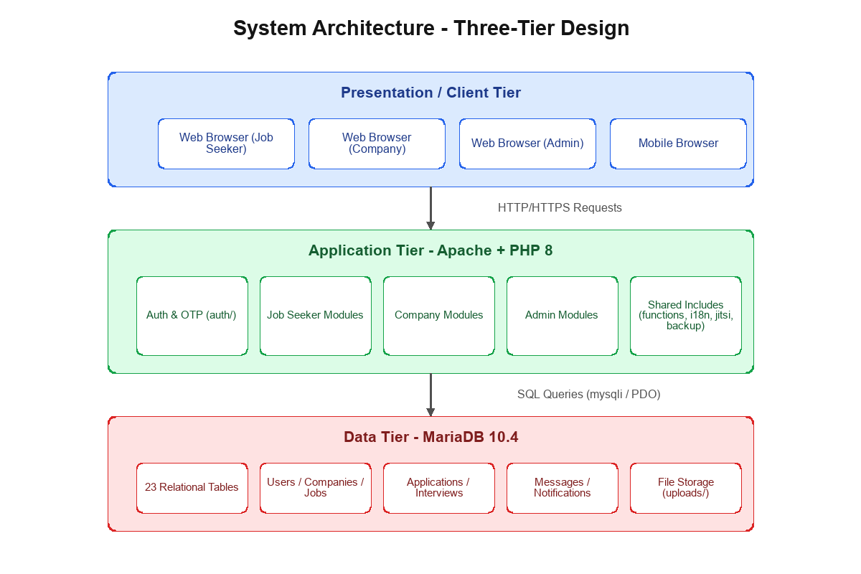
Figure 3.2: Three-tier system architecture of Somali Fix Jobs (client/browser, Apache + PHP application layer, MariaDB data layer).

3.8.2 Database Design
The system is backed by a relational MariaDB database of 23 tables, each serving a distinct concern within the platform. The table below summarizes the purpose of every table, drawn directly from the live schema.
Table | Purpose
users | Core account record for every person in the system (job seeker, company contact, admin, content writer, etc.), including role, status, and authentication provider.
tokens | Short-lived tokens for email verification, password reset, and OTP flows, linked to a user.
pending_registrations | Holds a job seeker registration until its OTP is verified, before a permanent user row is created.
profiles | Extended job seeker profile data: headline, bio, links, CV file, profile visibility, and completion percentage.
skills | Named skills with a proficiency level, linked to a job seeker.
education | Education history entries (institution, degree, field, years) linked to a job seeker.
experience | Work experience entries linked to a job seeker.
certificates | Certificates/credentials with an optional file, linked to a job seeker.
projects | Portfolio projects linked to a job seeker.
companies | Company profile and verification/approval status, linked one-to-one with a user account.
jobs | Job listings posted by a company, including type, salary range, skills, and status.
internships | Internship listings posted by a company, including duration, payment terms, and capacity.
applications | A job seeker's application to a job or internship, tracking status through the review pipeline.
interviews | A scheduled interview linked to an application, including its date, time, and status.
bookmarks | Jobs a job seeker has saved for later.
chat_rooms | A one-to-one messaging thread between two users.
messages | Individual chat messages within a chat room, supporting text and file/image attachments.
notifications | In-app notifications delivered to a user (e.g. interview scheduled, application status changed).
blogs | Blog posts authored by a content writer or admin, with full-text search support.
contact_messages | Submissions from the public Contact Us form.
activity_logs | An audit trail of significant system actions (logins, approvals, deletions, settings changes) for accountability.
settings | Key-value store for site-wide configuration (branding, appearance, maintenance mode, etc.).
partners | Partner/sponsor organizations displayed on the public site.

Foreign keys enforce referential integrity throughout — for example, applications cascade-delete when their parent job seeker, job, or internship is removed, and interviews cascade-delete with their parent application. The entity-relationship diagram below groups the tables by functional category: identity/profile (blue), company/listings (amber), transactional (green), communication (purple), and content/system (red).
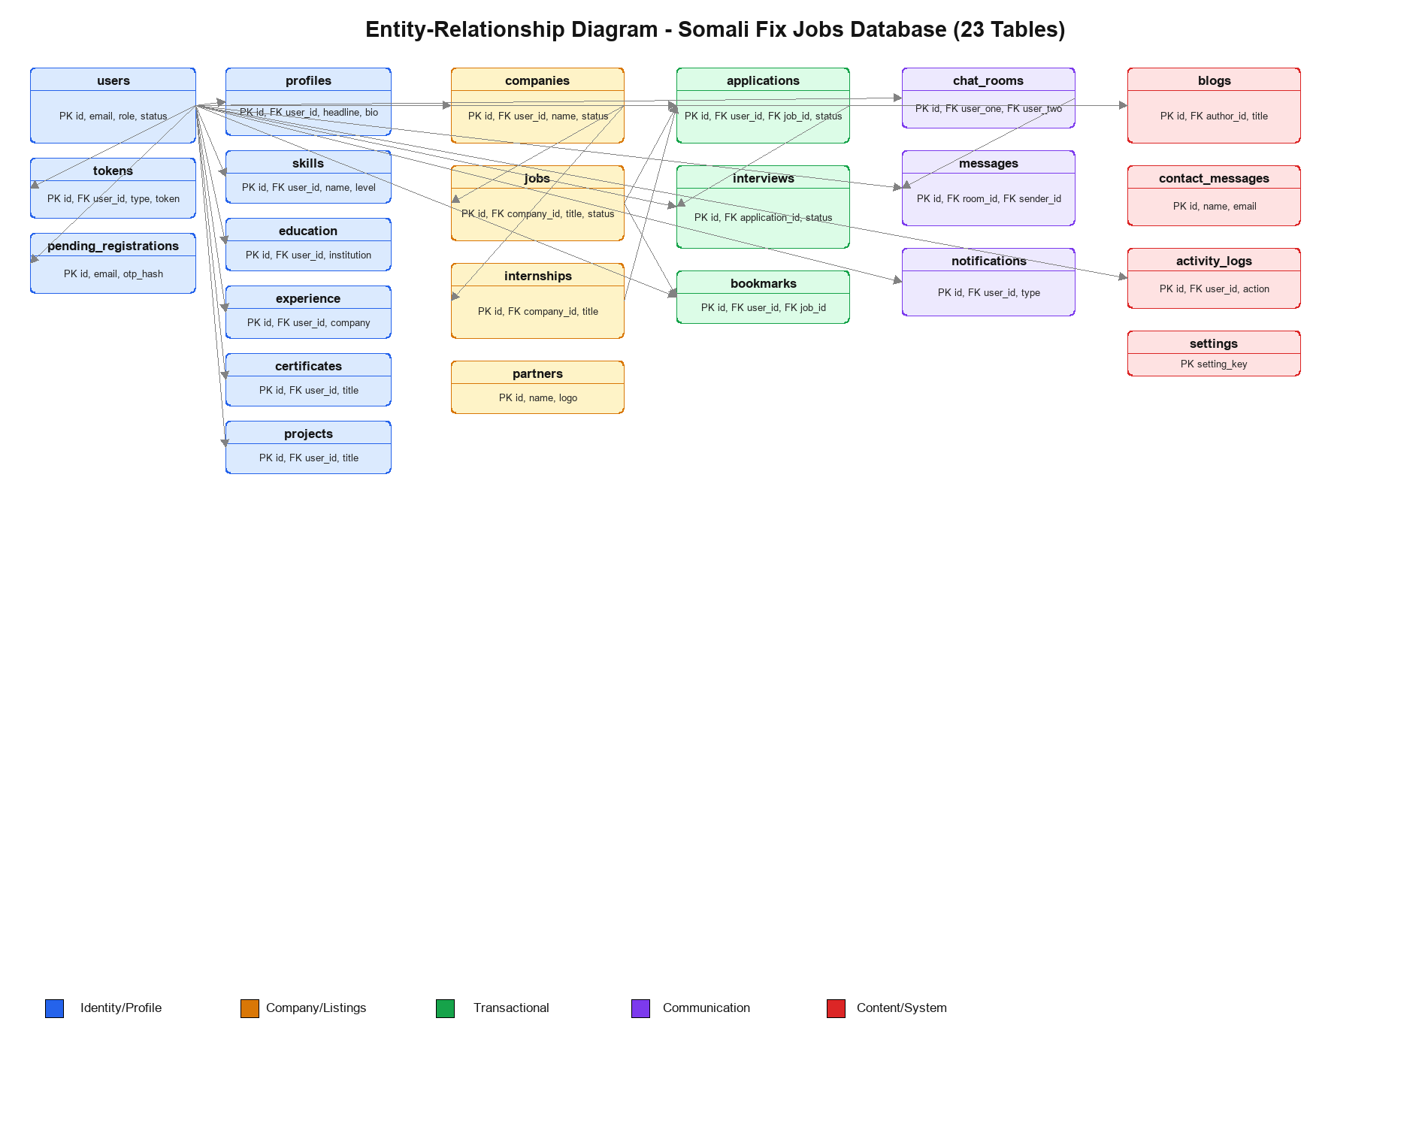
Figure 3.3: Entity-relationship diagram of the Somali Fix Jobs database, showing all 23 tables grouped by functional category with their primary/foreign key relationships.

3.8.3 UML Diagrams and Flowcharts
Two flowcharts document the two most important cross-cutting processes in the system: account registration with OTP verification, and the full lifecycle of a job application.
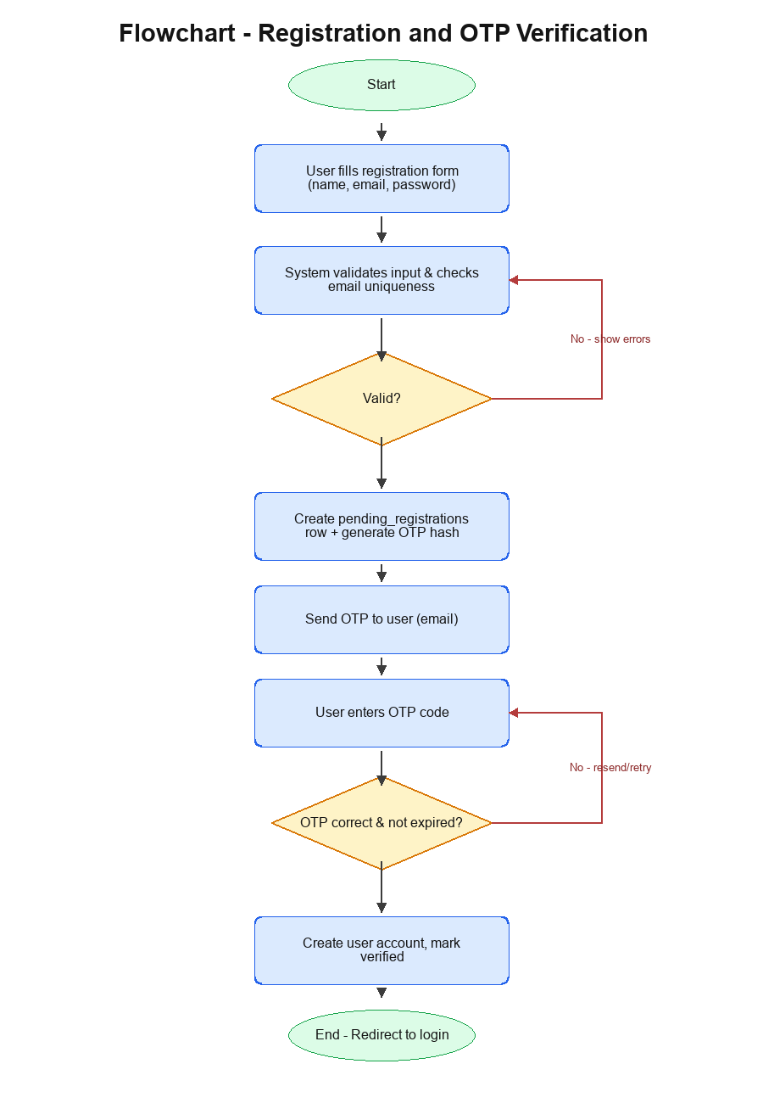
Figure 3.4: Flowchart of the registration and OTP verification process.

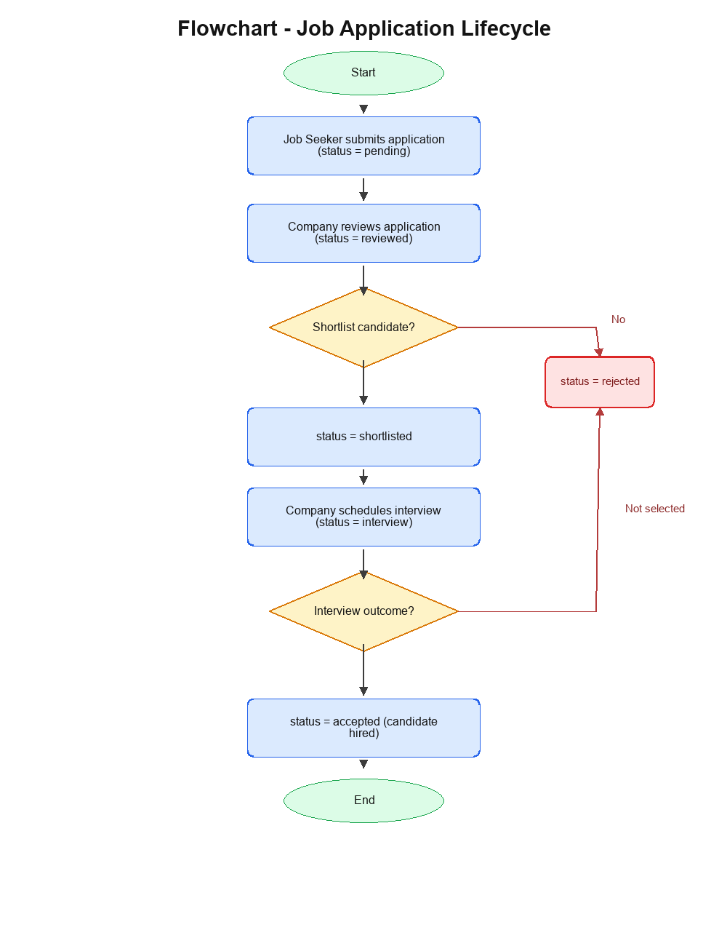
Figure 3.5: Flowchart of the job application lifecycle, from submission through review, shortlisting, interview, and final outcome.

3.8.4 User Interface Design
The user interface was designed around role-specific dashboards built with Tailwind CSS and Font Awesome, favoring a clean, mobile-responsive layout consistent across the public site, job seeker portal, company portal, and admin portal. Rather than static mockups, the interface was iterated directly against the running application, and the actual, live screens produced by this process are presented as figures throughout Chapter Four, organized by portal (public/auth, job seeker, company, and admin), where each screenshot is paired with the test case it demonstrates.

3.9 Hardware and Software Requirements
Component | Requirement
Server-side language | PHP 8.2 (procedural style, no framework)
Database | MariaDB 10.4 (MySQL-compatible, InnoDB engine)
Web server | Apache HTTP Server, bundled via XAMPP for local development
Frontend styling | Tailwind CSS (via CDN)
Icons | Font Awesome
Minimum server specs | A single low-cost VPS or shared hosting plan is sufficient — 1 vCPU, 1-2 GB RAM, and a few GB of disk storage for the application and uploaded files, given the platform's data volume.
Client requirements | Any modern desktop or mobile web browser with JavaScript enabled (e.g. Chrome, Firefox, Edge, Safari); no browser plugin or app install is required.

3.10 Chapter Summary
This chapter analyzed the informal, fragmented state of job seeking that motivated Somali Fix Jobs, described the iterative, applied development methodology used to build it, and specified its functional and non-functional requirements. It established the technical, economic, operational, and schedule feasibility of the project, analyzed its use cases across four actor roles, and presented the full system design — a three-tier architecture, a 23-table relational database, and the key process flowcharts governing registration and job applications. Chapter Four documents how this system was tested, the results of that testing, and the documentation of its working screens.

REFERENCES
Allden, N., & Harris, L. (2013). Building a positive candidate experience: Towards a networked model of e-recruitment. Journal of Business Strategy, 34(5), 36–47.
Boehle, S. (2000). Online recruiting and the automation of applicant management. Training, 37(8), 30–38.
Bootstrap. (2025). Bootstrap documentation. https://getbootstrap.com
Cappelli, P. (2001). Making the most of on-line recruiting. Harvard Business Review, 79(3), 139–146.
Davis, F. D. (1989). Perceived usefulness, perceived ease of use, and user acceptance of information technology. MIS Quarterly, 13(3), 319–340. https://doi.org/10.2307/249008
Flanagan, D. (2020). JavaScript: The definitive guide (7th ed.). O'Reilly Media.
Glassdoor. (2025). Glassdoor. https://www.glassdoor.com
Indeed. (2025). Indeed. https://www.indeed.com
Laudon, K. C., & Laudon, J. P. (2022). Management information systems: Managing the digital firm (17th ed.). Pearson.
LinkedIn. (2025). LinkedIn. https://www.linkedin.com
MySQL. (2025). MySQL 8.0 Reference Manual. Oracle Corporation. https://dev.mysql.com/doc/
Narayanan, V. K., Olk, P. M., & Fukami, C. V. (2010). Determinants of internship effectiveness: An exploratory model. Academy of Management Learning & Education, 9(1), 61–80.
Nielsen, J. (2012). Usability 101: Introduction to usability. Nielsen Norman Group. https://www.nngroup.com/articles/usability-101-introduction-to-usability/
Parry, E., & Tyson, S. (2008). An analysis of the use and success of online recruitment methods in the UK. Human Resource Management Journal, 18(3), 257–274.
PHP Group. (2025). PHP documentation. https://www.php.net/docs.php
Sommerville, I. (2016). Software engineering (10th ed.). Pearson.
W3C. (2025). CSS: Cascading Style Sheets. https://www.w3.org/Style/CSS/
W3C. (2025). HTML Standard. https://html.spec.whatwg.org/
W3Schools. (2025). AJAX tutorial. https://www.w3schools.com/xml/ajax_intro.asp

